|  |  |  |
| --- | --- | --- |
| higher education  Department:  Higher Education and Training  REPUBLIC OF SOUTH AFRICA   |  |  | | --- | --- | | |  | | --- | | MARKING GUIDELINE | |   NATIONAL CERTIFICATE  APRIL EXAMINATION  STRENGTH OF MATERIALS AND STRUCTURES N5  9 APRIL 2014  This marking guideline consists of 6 pages,  Copyright iseserved Please turn over |

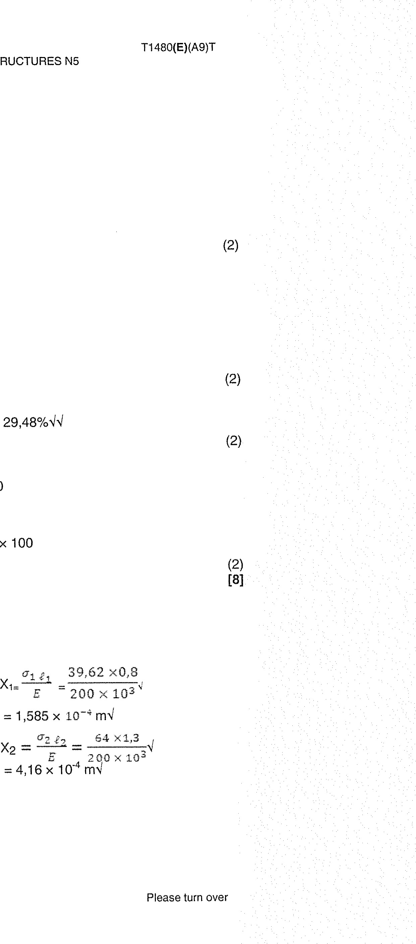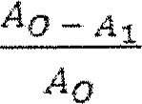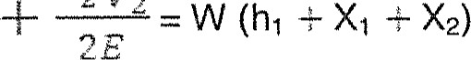1 max load

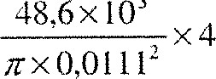

48.6x

1 .1

Tensile strength 

.40

502,23 MPaqq

1 .2

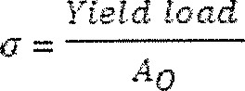

{cad

20.5 x 103 x 4

- 211 MPaqq

# 18 72,9-563

Percentage elongation = x 100 = 29,480/044

56>3

1 .4

Percentage reduction in area =x 100

11,12 -7>98 2

x 100

1 1, 12

= 48,320/044

## QUESTION 2

39/62 xo,8

E - 200 x 10

### 0,0026

 x 644 = 1,585 x rm!

#### 54 Xl,3

= 39,62 MPaq X2 = ¯

200 x 10

4116 x 4 mq

Gain is strain energy = Loss in potential energy

### 52 VI 52 V2

1

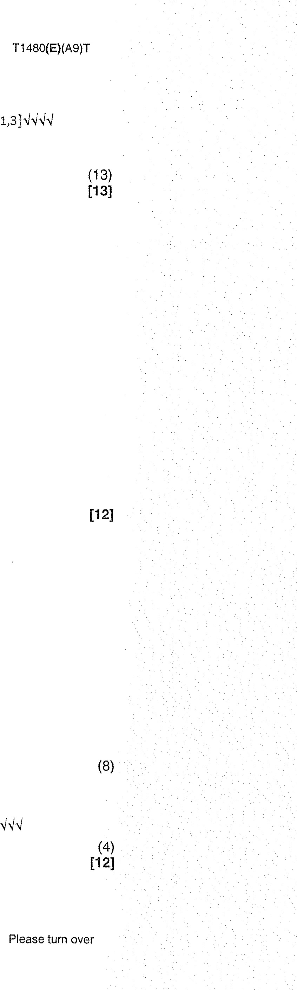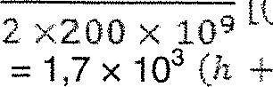[(39,6210 é )2 0/3026 X 1,351MQN/

1,585 •x4.16 x 10

= 27,54

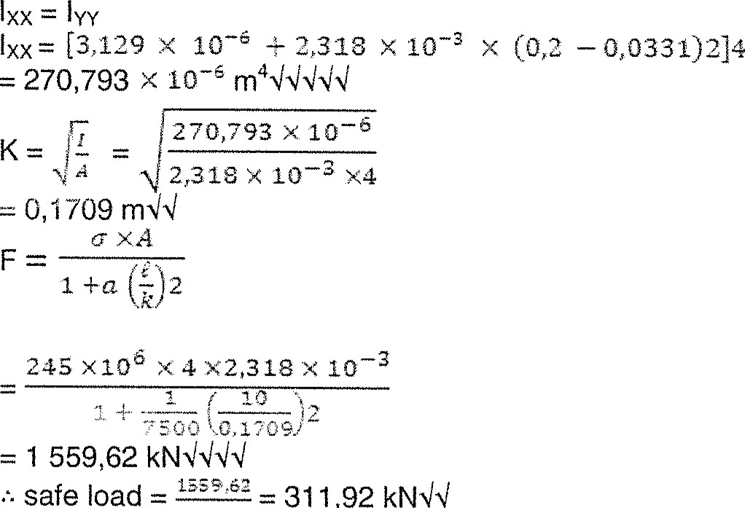

QUESTION

3

5.

## QUESTION 4

4.1 

## X (12 X 50 X 5) = X (50 X 15)

At (aa — db)

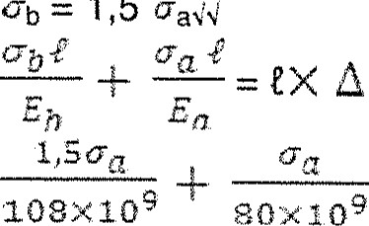

=

1,5

= 70— 16 x

|  |  |  |
| --- | --- | --- |
|  | 15,92 MPa  15,92 x 1,54  = 23,87 MPaNl |  |
| 4.2 | Final length = e + |  |
|  | - 630 +630 x 16 x -10- | 23987x63Q  x 70 |

108x103

- 630,8448



5

5.1

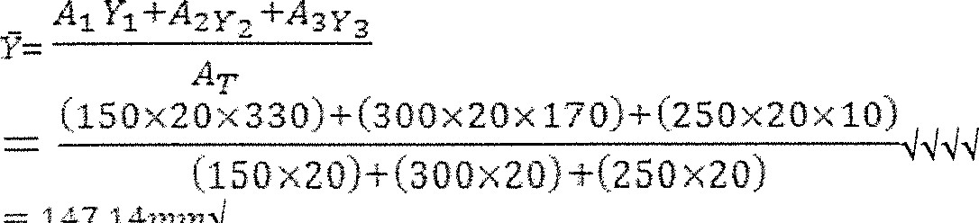

'147.147727701

### 5.2 (150 X ZC X 22 362)

+ (20 x 250 x 137.14 2 > — 242.752 x

5.3

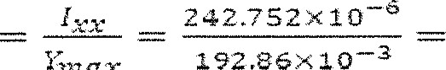 z 1258.7 x 10-

max

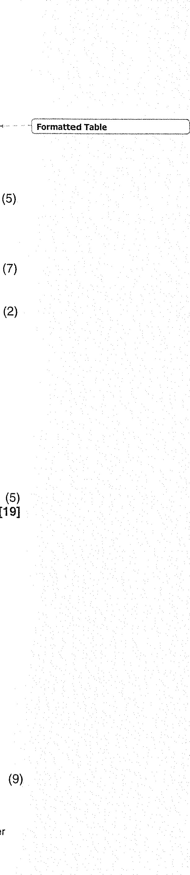5.4

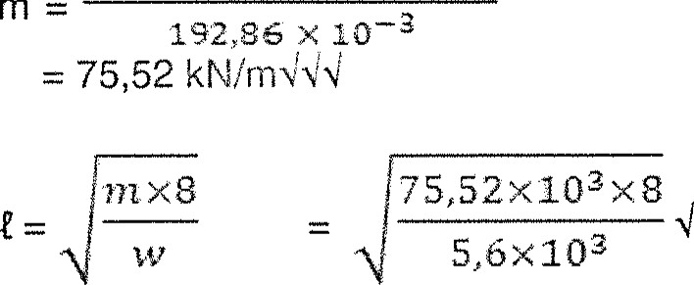

60XIObX242,752X10-b

=

10,39

rnq

## QUESTION 6

6.1 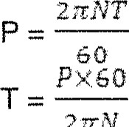

1300xeo

= 105 204,149 Nmqq

2nx118

 = X 1052C4v1149

= 140 973,51 Nmq

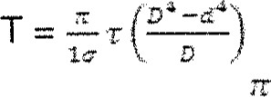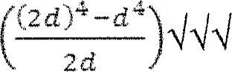140 973,51 = —x 56 x 10 6

16 d = 119,57 mmq D = 239,14 rnmq

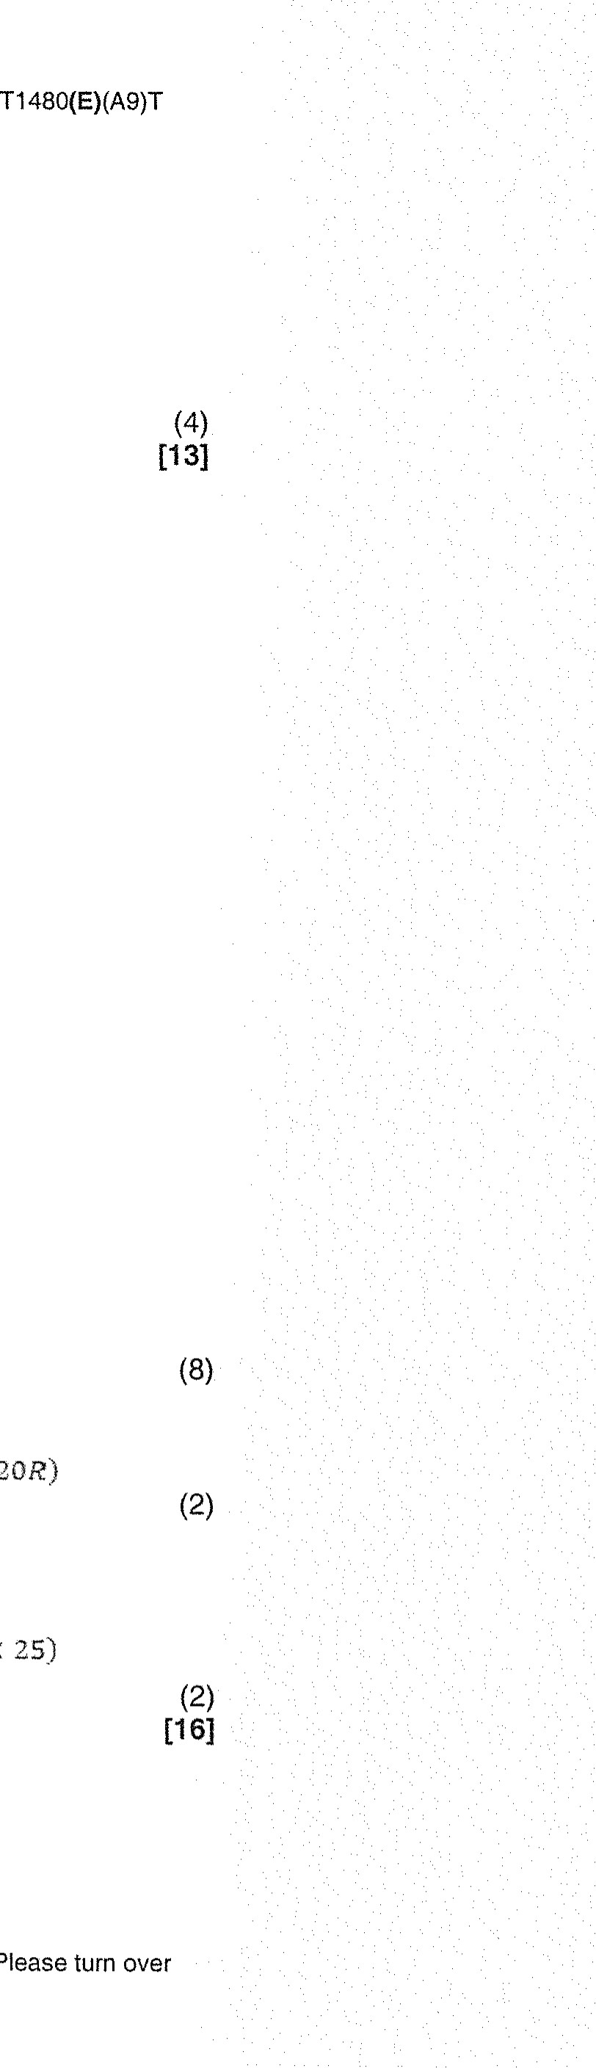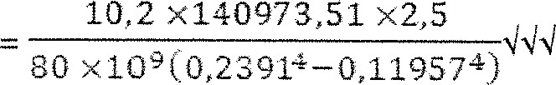6.2

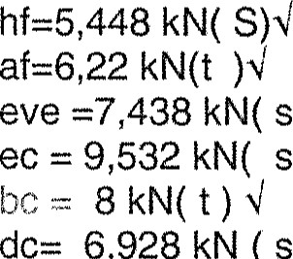

6,928

kN

(s

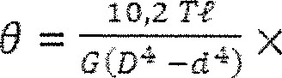

10,2

## QUESTION 7

g

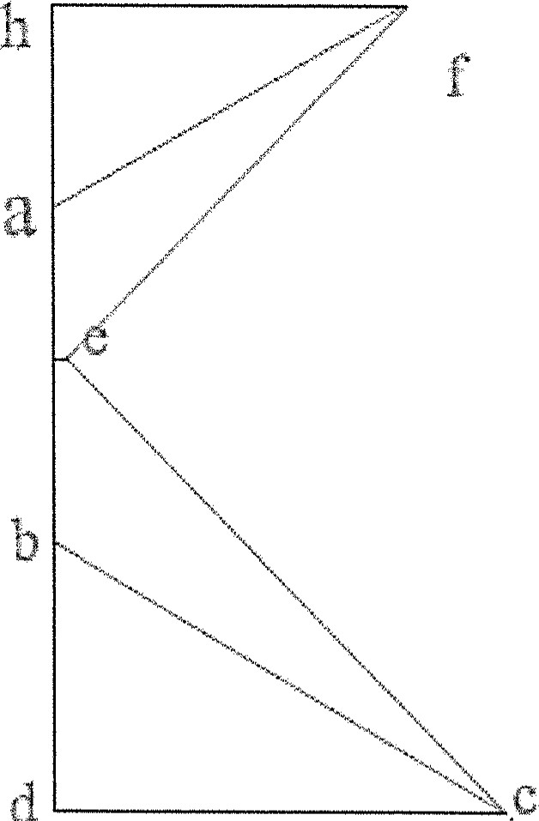

d

CM = ACM

# (5 X 10') + (14 X 25,) = (3 X 5) + C20R)

R = 6.75k,vqq s hi

(6) CM = ACM

X 5) + (.20L) = (15 x 10) + (3 25)

L = 5i25kNqq

(8)

|  |  |
| --- | --- |
|  | x IO O xD |

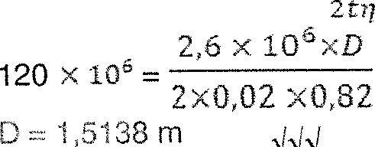-6-

8

Circumferential stress = —

Longitudinal stress = —

s,ät

0902 x 0,04 D = 1,6246 m use D = 1,6246 rn•l